Chapter 1: Introduction

* Only in India nearly 1.5 people die in road accidents and majority of them are due to two wheelers.
* And most of death happen due to not wearing helmet and it can prevented using our project.
* Rider safety system detects were the rider is wearing helmet or not, if the rider is not wearing helmet and he/she try to start the bike, the bike will not going to start.
* If rider is wearing helmet and he/she tries to start bike, bike will start and this system can save many life’s.

Chapter2: Literature Review

**SMART HUMAN TWO WHEELERSAFETY SYSTEM**

**Abstract -** *Set, check and Go to have safe and happy drive. In this project, we proposed that bike system to check whether the rider wears the helmet or not then after only it will start to go else it won’t start. This project is developed under the safety precaution for the people to value human being’s life. The helmet has in built sensor like alcohol sensor, touch sensor, IR sensor and etc. These are used to send the information that all are ok and the start signal is transmitted to receiver which is located at bike. After receiving the start signal then only the bike starts else it will wait for the signal. The RF transmitter and receiver is used here to communicate between helmet and bike. Our system will set everything first then check the requirement to start the bike. A vibration sensor is placed in bike which is detects the accident to make an alert to rider.*

**Chapter 3: Block Diagram and Working**

**1.1 Discussing Methodology**

1) When rider wears the helmet the button inside the button gets pushed.

2)Button will send the signal to encoder and encoder will send signal to rf transmitter which transmit data.

3)Rf receiver will receive the data and send to decoder.

4)Now decoder sends signal to relay which connects the ignition to battery and bike will be ready to start.

**1.2 Block Diagram**

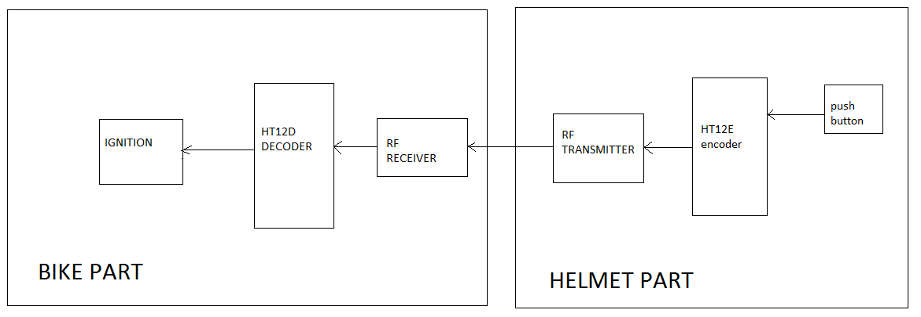

Circuit diagram

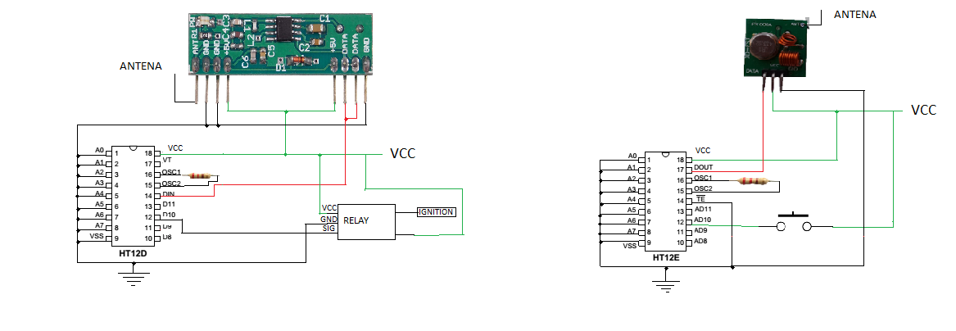

Chapter 4: Hardware overview

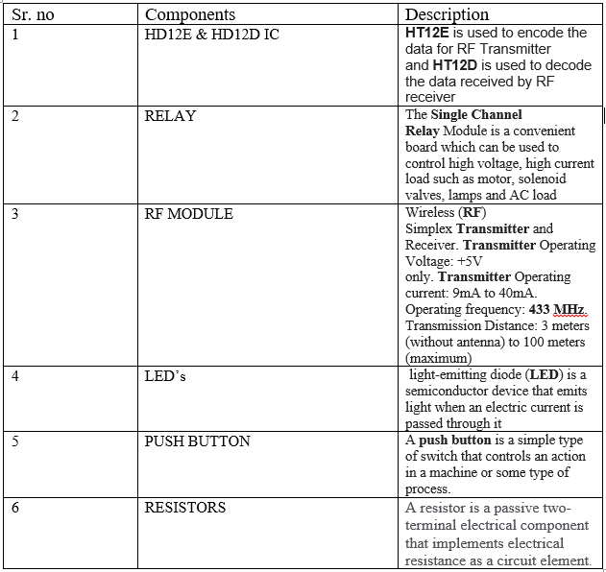

Conclusion:

At the end of the project, the system should make’s it mandatory for the rider to wear a helmet before riding a two wheeler.

We came to the conclusion that

it is the best way to reduce the accident and number of head

injury happening in road. This is a very innovative idea. That

should be developed further for improvements.

Reference:

[www.allaboutcircuits.com](http://www.allaboutcircuits.com/)

www.novanprojects.com

**www.irjet.net**